**Консультация зачет**

**Выбираете схему**

**Левая схема с одним R1 на оценку “4”, правая схема с двумя R на “5”**

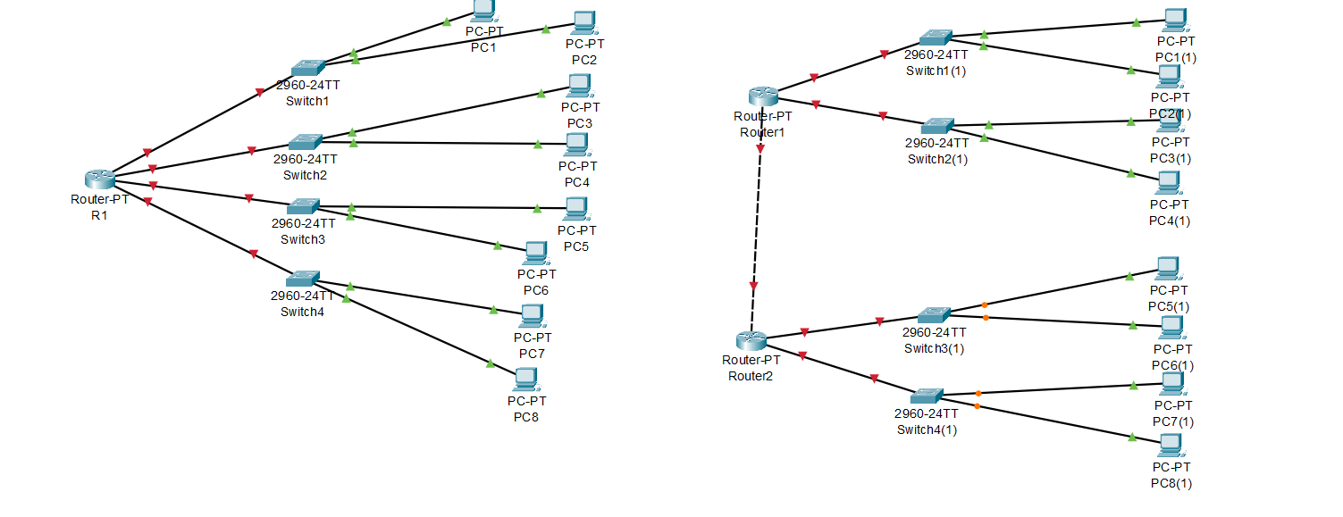

**Далее выбираем свой вариант согласно журнала**

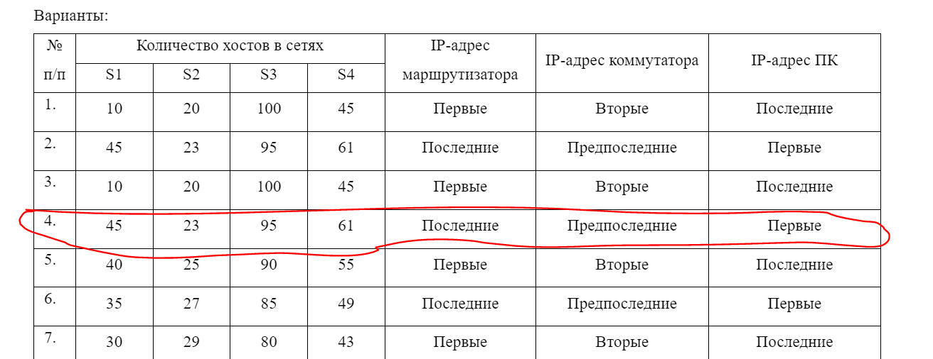

**Деление на подсети вы должны задать каждый сетке необходимую маску**



**255.255.255.0 / 24 254**

**192.168.1.0 /24 1.**

| **128** | **64** | **32** | **16** | **8** | **4** | **2** | **1** |
| --- | --- | --- | --- | --- | --- | --- | --- |
| **25** | **26** | **27** | **28** | **29** | **30** | **31** | **32** |
| **128** | **192** | **224** | **240** | **248** | **252** | **254** | **255** |
| **126** | **62** | **30** | **14** | **6** | **2** | **-** | **-** |

**.254 0-адрес сети 255-broadcost**

**s1 /26**

**S2 / 27**

**S3 /25**

**S4 /26**

**192.168.0.0 /23 512 -2 =510**

**S3 - 192.168.0.0 /25 .. 0.. 127 (1..126)**

**S4 - 192.168.0.128/26 128-191 (129..190 )**

**S1 - 192.168.0. 192 /26 192 - 255 (193 .. 254)**

**S2 192.168.1.0 /27 0 - 31 (1..30)**

| **R1** | **G0/0** | **S1** | **192.168.0.254** | **255.255.255.192** |  |
| --- | --- | --- | --- | --- | --- |
| **G0/1** | **S2** | **192.168.1.30** | **255.255.255.224** |  |
| **G0/2** | **S3** | **192.168.0.126** | **255.255.255.128** |  |
| **G0/3** | **S4** | **192.168.0.190** | **255.255.255.192** |  |
| **S1** | **vlan1** | **R1** | **192.168.0.253** | **255.255.255.192** | **192.168.0.254** |
| **S2** | **vlan1** | **R1** | **192.168.1.29** | **255.255.255.224** | **192.168.1.30** |
| **S3** | **vlan1** | **R1** | **192.168.0.125** | **255.255.255.128** | **192.168.0.126** |
| **S4** | **vlan1** | **R1** | **192.168.0.189** | **255.255.255.192** | **192.168.0.190** |
| **PC1** | **FE1** | **S1-FE0/1** | **192.168.0.193** | **255.255.255.192** | **192.168.0.254** |
| **PC2** | **FE1** | **S1-FE0/2** | **192.168.0.194** | **255.255.255.192** | **192.168.0.254** |
| **PC3** | **FE1** | **S2-FE0/1** | **192.168.1.1** | **255.255.255.224** | **192.168.1.30** |
| **PC4** | **FE1** | **S2-FE0/2** | **192.168.1.2** | **255.255.255.224** | **192.168.1.30** |

**192.168.0.0 / 16**

**172.16.0.0 /12**

**10.0.0.0 / 8**